Project Report of Operating Systems
Project title: The Sleeping Barber Problem
Project number: Project 2
Course number: COSC 4337
Student's name: Ablasse Kingcaid-Ouedraogo
Date handed in: December 14, 2025

Table of Contents
- Problem Statement
- Project Analysis
- Desin & Class Prototype
- Testing and sample results
- Conclusion

Problem Statement
Create a synchronized, multithreaded simulation of a barbershop with one barber, one barber chair, and a waiting room with three chairs. The barber sleeps when there are no customers. Customers arrive at random intervals, if the barber is asleep, they wake him up. If the barber is busy, they will wait in the waiting room if there are chairs available, otherwise they leave. The program will coordinate barber and customers using Java threads and wait()/notify() to avoid race conditions.

Project Analysis
Inputs: simulated customer arrivals (16 customers, IDs 0–15) created on an asynchronous thread with 1–2000 ms random delay.
Waiting Room: Capacity of 3 customers, tracked through: availableChairs = waitingChairs - occupiedChairs, queue of waiting customers.
Outputs: console log statements for each event (enter, wait, leave, barber sleep/wake, start/finish haircut).
Deadlock risk: The current code does not deadlock. The only blocking state is the barber sleeping on an empty queue, he wakes when notified by arriving customers. After generation ends, the barber can sleep forever unless interrupted manually.

Design & Class Prototype
Algorithm overview:
- Customer generator thread creates customers with random delay(1ms-2000ms) and hands each to Shop.checkIn.
- Shop.checkIn adds the customer to the waiting queue if a chair is available, increments occupiedChairs, prints output, and notifies the barber; otherwise prints that the customer leaves.
- Barber thread calls Shop.getNextCustomer() which waits (lock.wait) while queue empty, wakes, pops next customer, decrements occupiedChairs, simulates a haircut, and prints progress.
Class prototypes (public surface):
class Main {
public static void main(String[] args);
}
class Shop {
public static Shop getInstance();
public void checkIn(Customer customer);
public static Customer getNextCustomer();
public static int getAvailableChairs();
public static Object getLock();
}
class Barber {
public static Barber getInstance(Object lock);
public Thread getThread();
}
class Customer {
public Customer(int id, Shop shop);
public int getId();
public Thread getThread();
}

Testing and sample results
- The code uses print statements for debug logging.
- The primary testing mechanism is the generateCustomers method. It automatically creates a new customer on random, customizable intervals.

- I ran 2 tests, expecting the same sequential processing of customers:
  - The first test was with the customer generation interval being between 1-10ms –
    - The purpose was to test the robustness of the synchronization methods. When synchronization is suboptimal, this interval range will cause customers to be processed in seemingly random order.

  - The second test was the validation of general functionality, testing the ability for customers, not only to be checked in, but also serviced by the barber at predictable intervals, push and popped from the waiting queue, and turned away when the chairs are full. The customer generation interval in this test is(1ms-2000ms).

Expected behavior: 16 customers arrive at random intervals and are checked in using the order that they arrived. At most 3 customers waiting at any given time, while the extras leave. The barber cycles between sleeping and cutting.

Test 1) 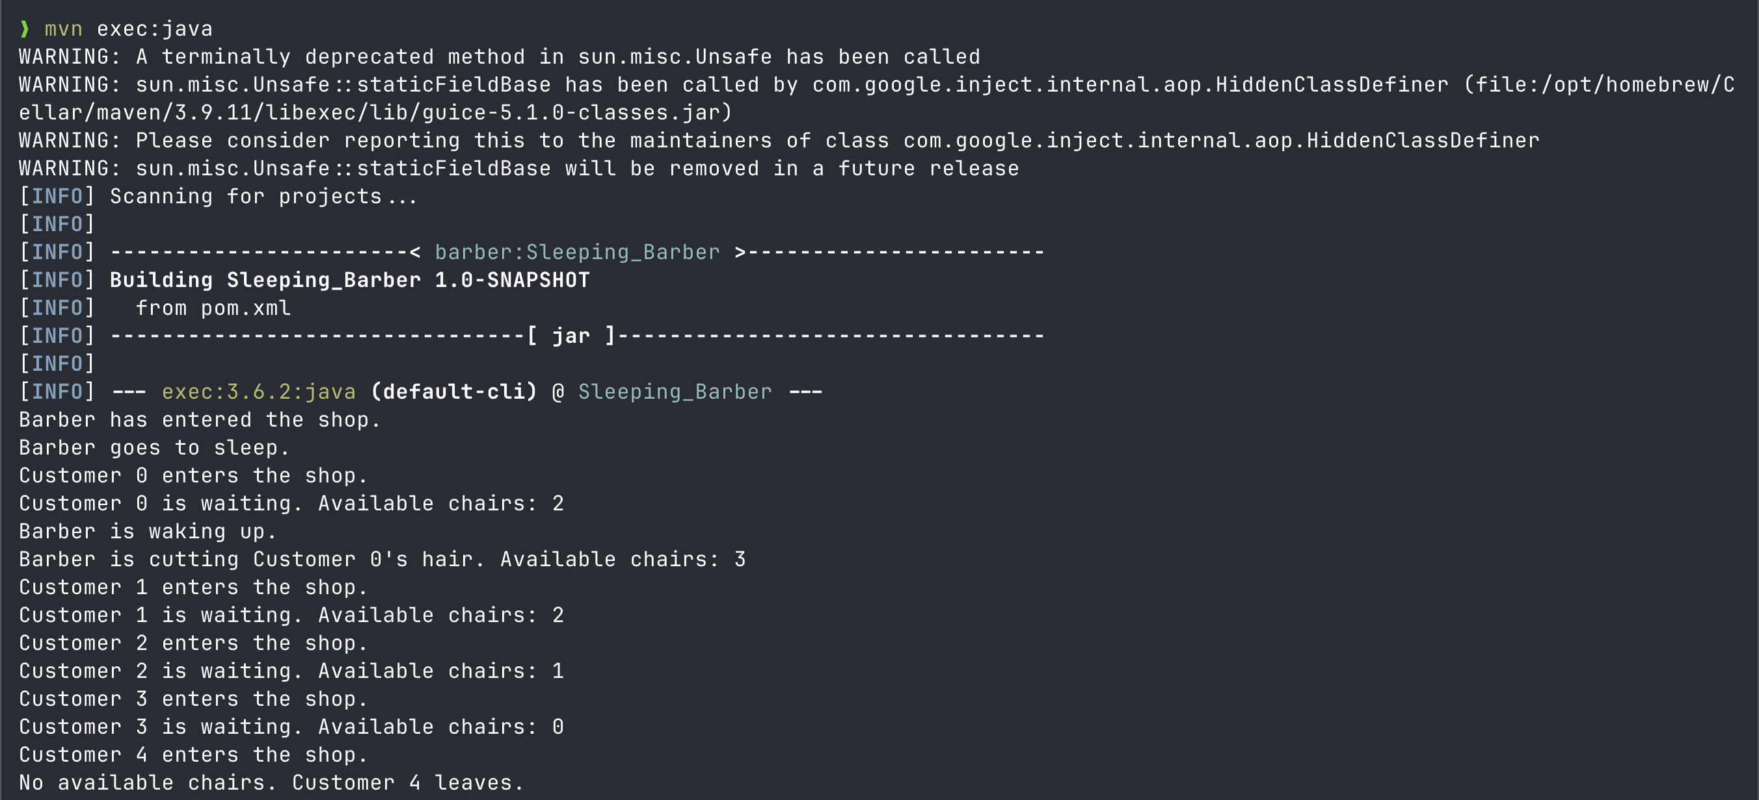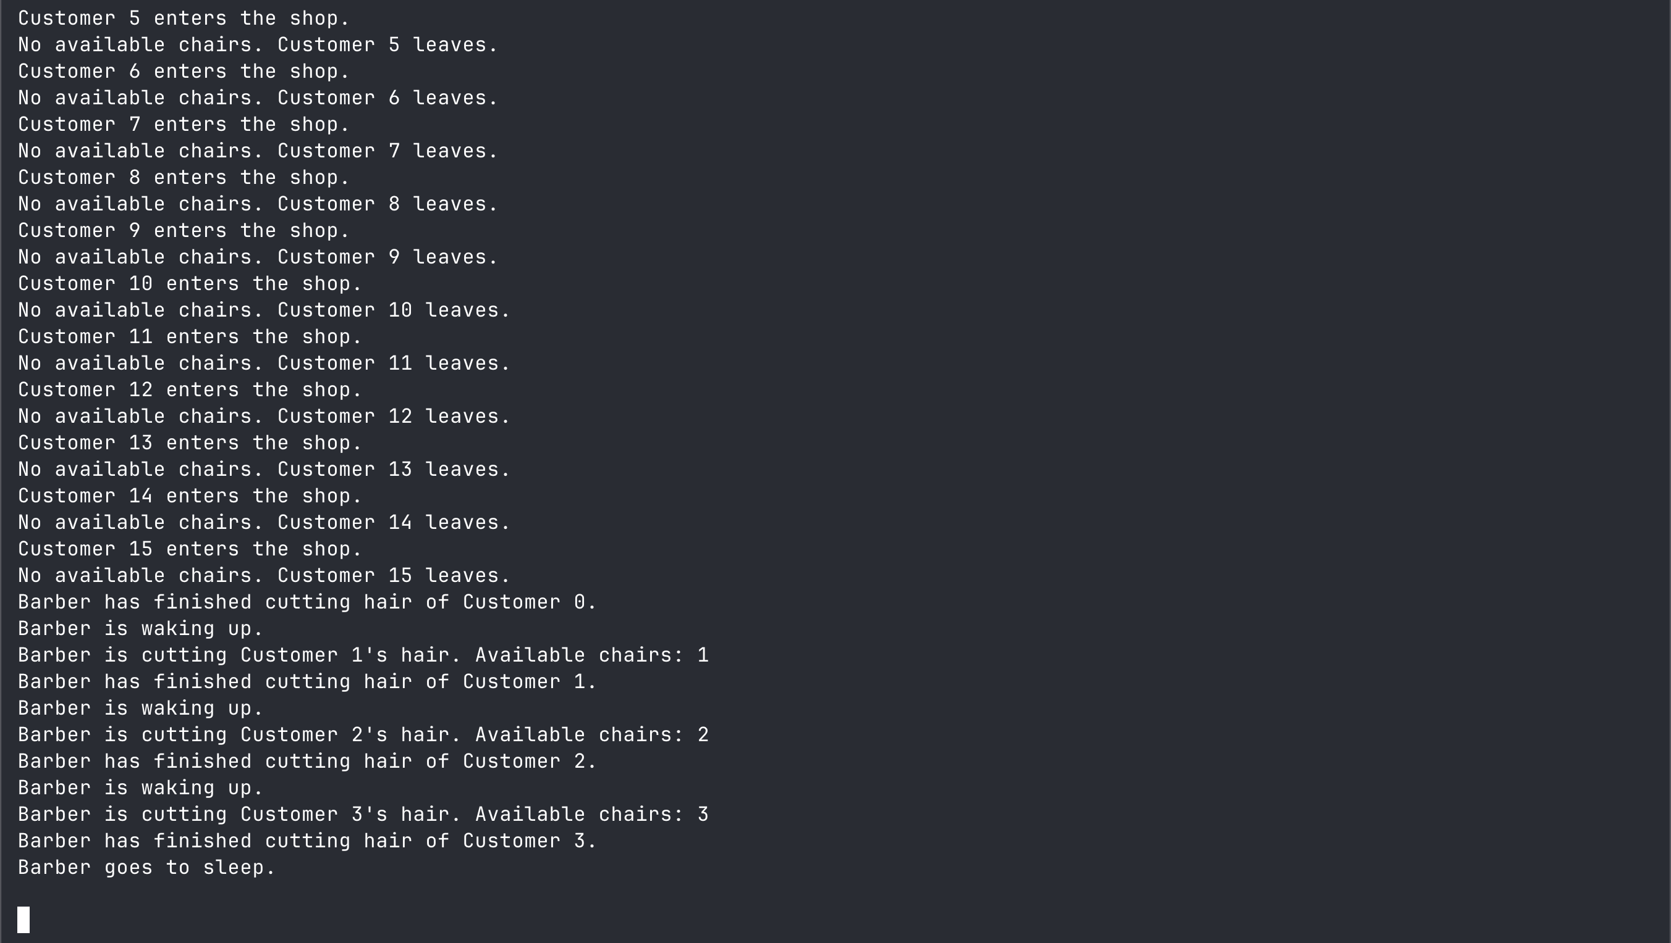

Test 2)
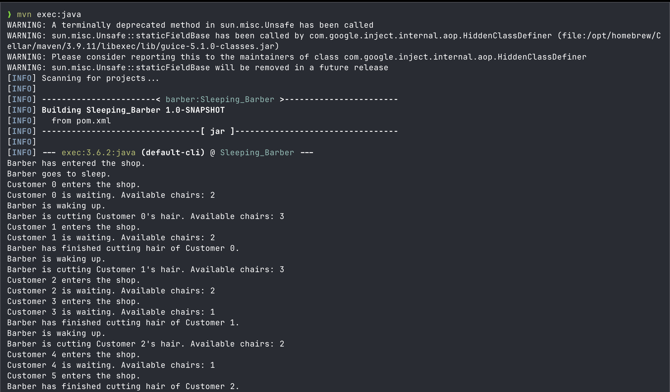
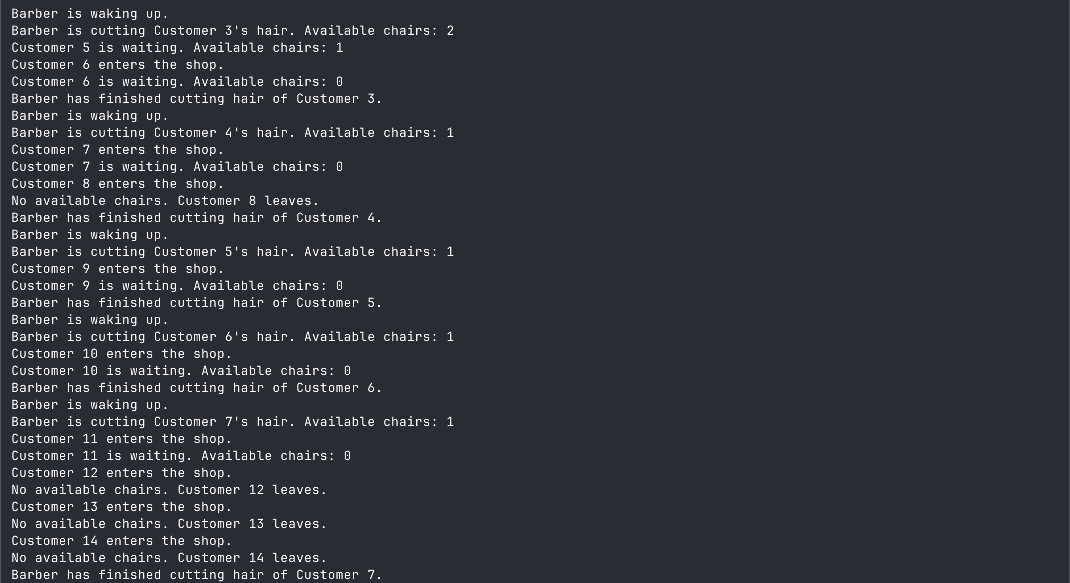
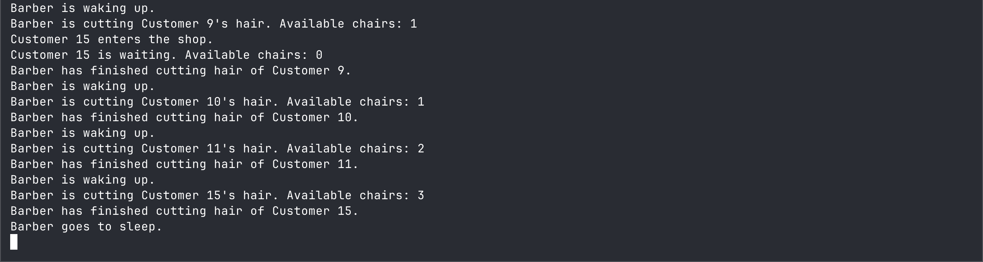

Conclusion
My sleeping barber implements synchronization using a single monitor and queue it avoids deadlock by design. The only inherent problem I can definitively point to in the architecture is the lack of an automatic shutdown that leaves the barber thread sleeping after work completes.

